

|  |
| --- |
|  |

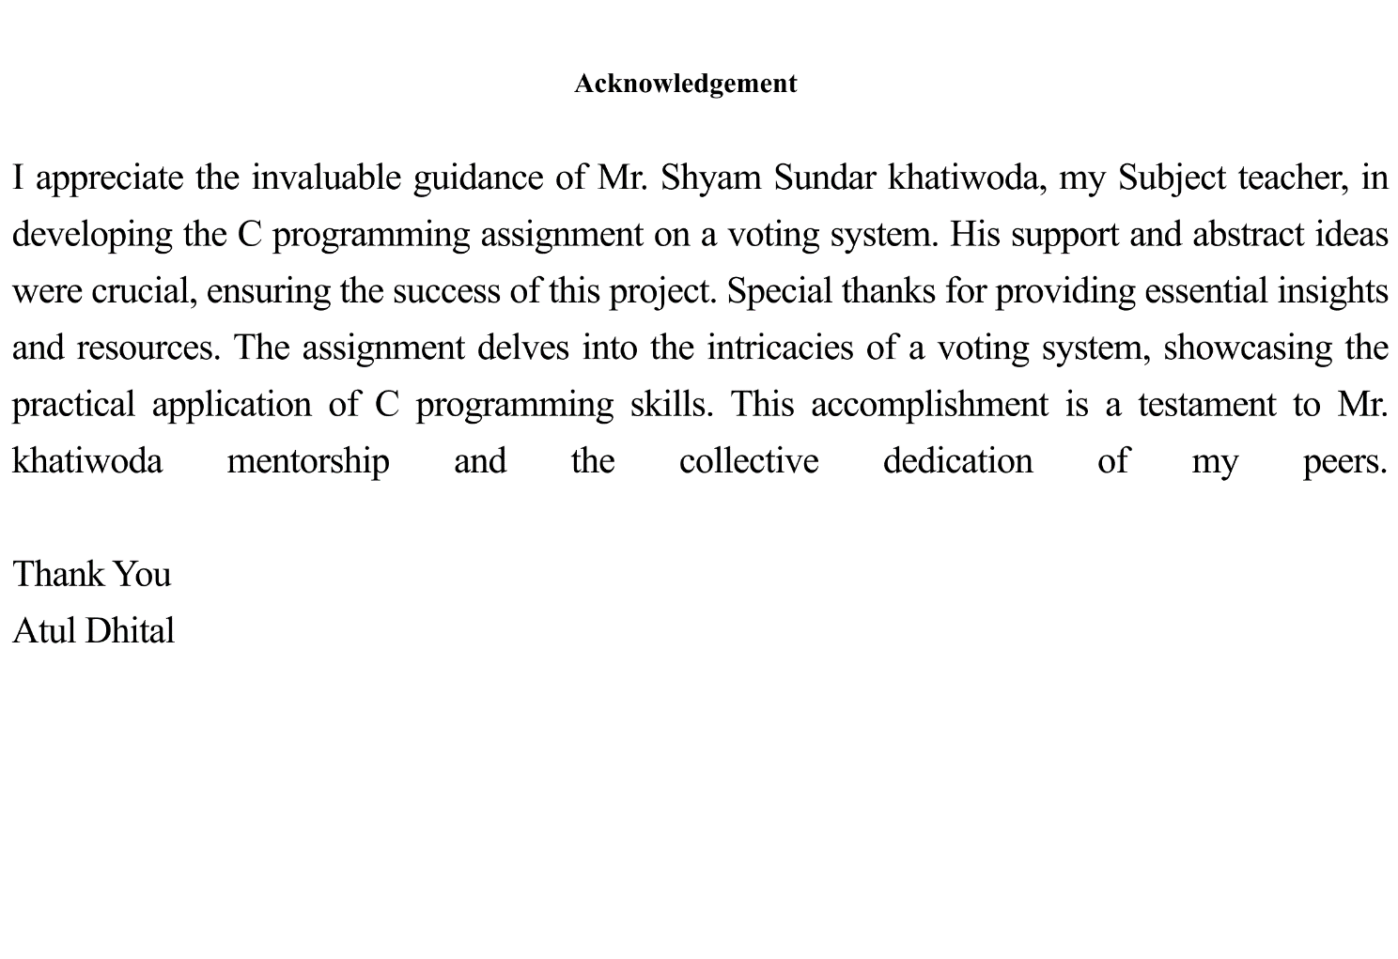

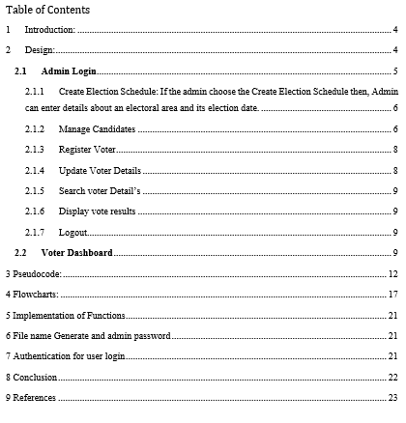

# Introduction:

The project named voting system is an attempt to create a unified software platform which can be used to manage an entire election process. Features include personnel management during an election, voting system including the registration of a new candidate and the capability to vote then transfer this vote to a different eligible candidate. This document covers the architecture of the project, the implementation and how the project adheres to the fundamental principles of fairness and transparency in democratic processes. As a development we are going to use c programing language.  
For this project, we will utilize C programming, which is a widely used programming language in Word. Windows and many other companies employ C as their primary programming language.   
If you understand C, you can quickly learn the other programming languages.

# Design:

The software is an Elections Management System (EMS) which allows users to finish an assortment of event-related duties. The primary menu has three options:

First we have a common interface for user or admin for when we run code:

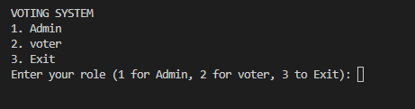

## **Admin Login**

After running the program if user can choose option 1 then we need to enter passcode to access the admin panel   
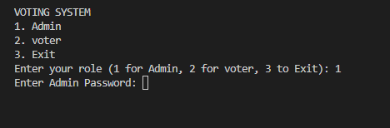

After entering the correct passcode the user can able to access the feature of admin dashboard of voting system.

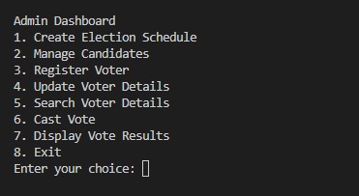

After getting access of admin side admin can do 7 tasks those are   
1. Create Election Schedule

2. Manage Candidates

3. Register Voter

4. Update Voter Details

5. Search Voter Details

6. Cast Vote

7. Display Vote Results

### Create Election Schedule: If the admin choose the Create Election Schedule then, Admin can enter details about an electoral area and its election date.

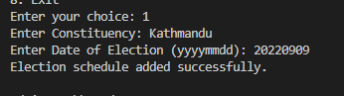

After, creating election date admin can return to the admin dashboard.

### Manage Candidates

After creating election admin can manage the candidates that is Add candidates to the candidate list, including their name, political party, and candidacy details. Also, admin can update and remove candidates from the list.

When admin choose manage candidates options there is 4 options that is

**Add Candidate**

After selecting 1 as the option for registering a candidate. Admin can add candidates for the election:   
where admin must input information about the candidates. Those are the name, party, and address.

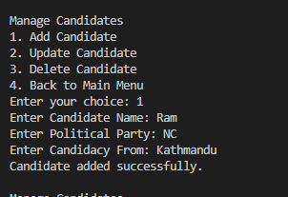

**Update Candidate**

If admin need to update candidates details admin should chose option 2 and enter name of the candidates:

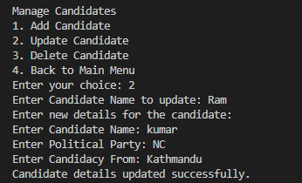

3. Delete Candidate

If admin wants to delete the candidates, admin shoul choose option 3 and enter the name to delete the candidates:

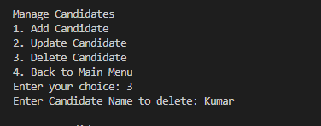

4. Back to Main Menu

If admin wants to get back to main dashboard admin should choose option 4.

### Register Voter

Administrators can register new voters by providing their serial number, name, date of birth, address, and password. By checking that the voter is at least 18 years old.

First admin will ask for age to ensure that voter was eligible for voting or not.

Then we need to enter serial number, Date of Birth, Address, and password of Voter.

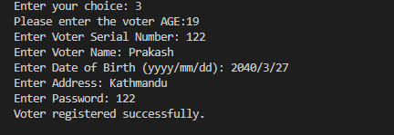

### Update Voter Details

Admin can update voter data by entering the serial number and updating the necessary information.

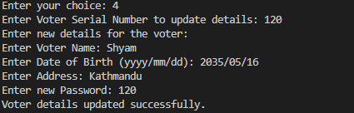

### Search voter Detail’s

Admin can search for and indicate details about a voter via the voter's serial number.

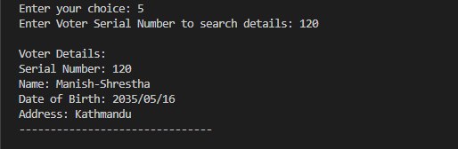

### Display vote results

Admin can publish the vote by entering number 7.

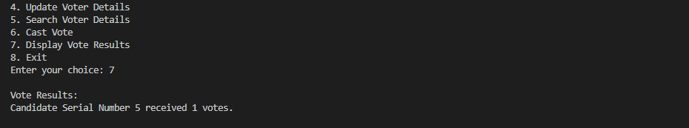

### Logout

The option 8 exit works as logout.

## **Voter Dashboard**

After running the program if user can choose option, then we need to enter passcode to access the voter panel:

To access the voter we need to login first where we need to enter serial number and password that was provided by the admin.

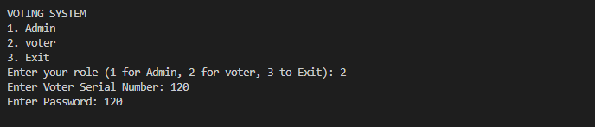

Voter can access the

1. voter can update the own details
2. Cast the vote
3. Display the results
4. Exit

**Update voter details**

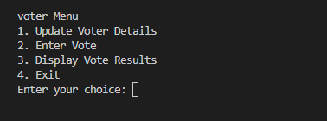

**Enter Vote**

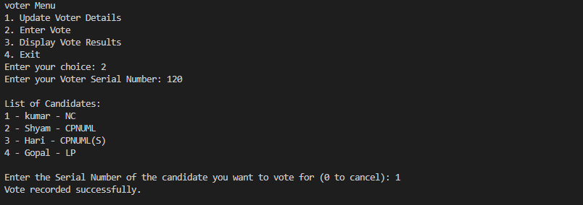

**Display Vote**

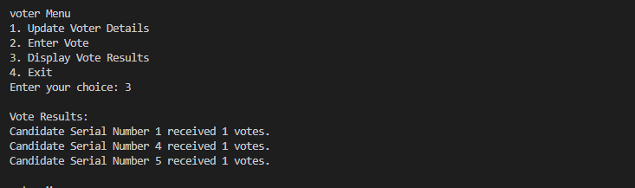

The sequence of my voting system is as follows: initially, we must start the software and then pick between admin and voter.

If the user chooses admin, he or she must provide a PIN to validate himself or herself. After successfully verifying the admin, he has many alternatives, for example:

Create voter.

Create candidates.

Create an election.

Update them with the display vote choices, as I said before.

On the other hand, within voter menu.

If the user chooses the voter option, he or she must authenticate oneself in order to vote, and after successfully logging in, they must select the choice for

Register to vote (cast a vote), edit your profile, and display your vote.

# Pseudocode:

C allows pseudocode, an informal programming language that improves human comprehension. Because it is written in plain English, the complicated software becomes more intelligible (geeksforgeeks, 2023).  
  
  
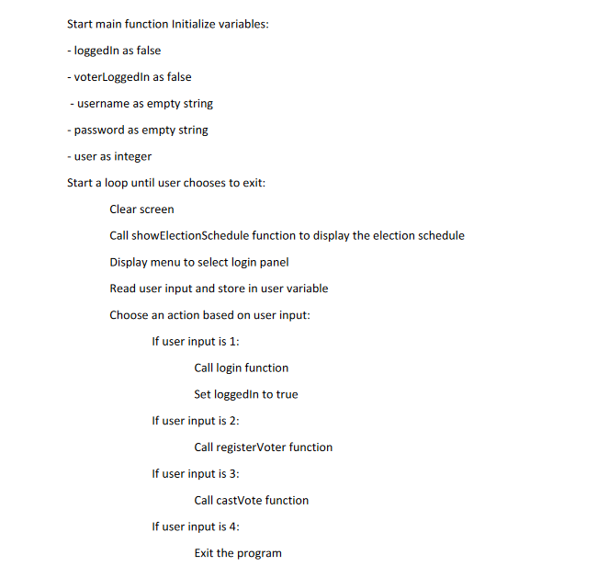

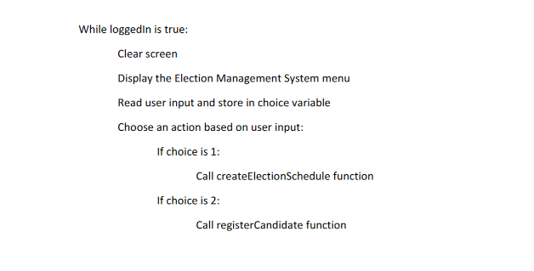

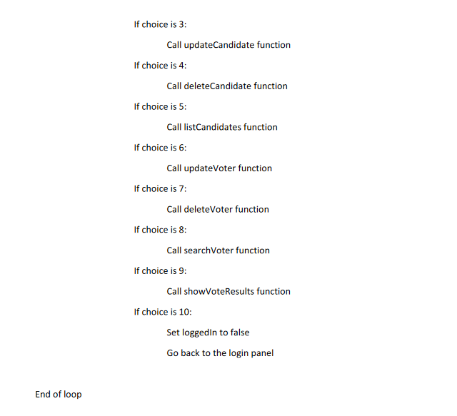

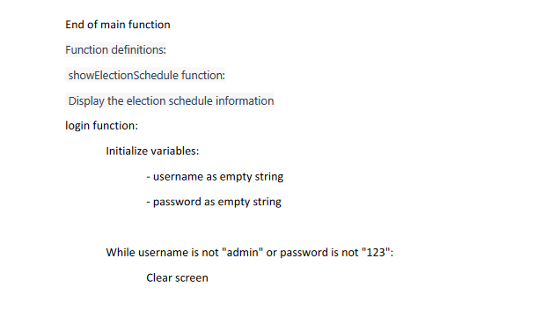

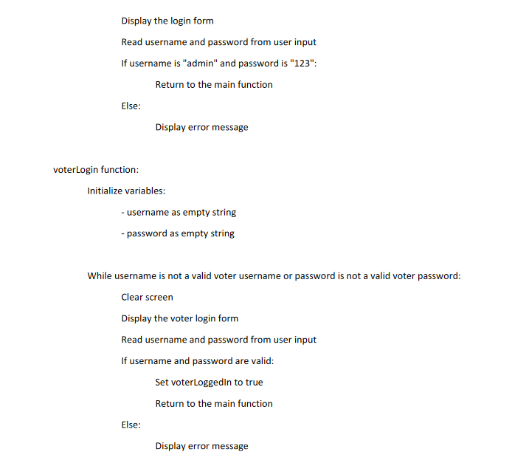

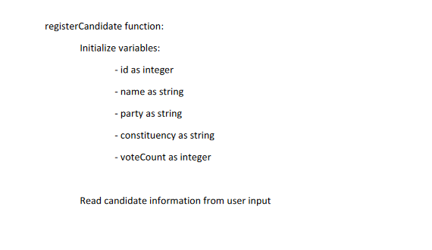

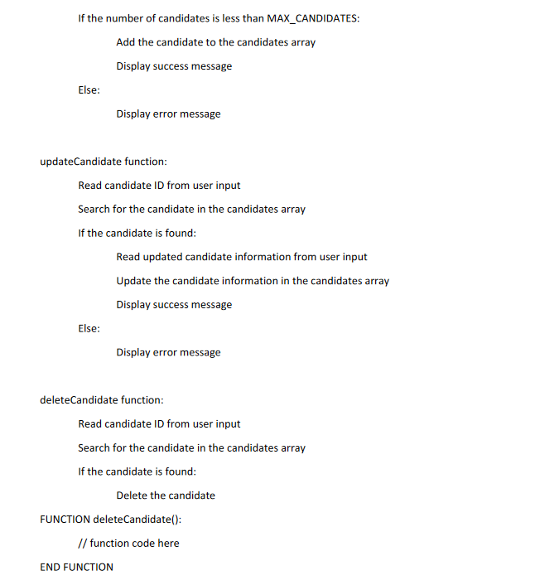

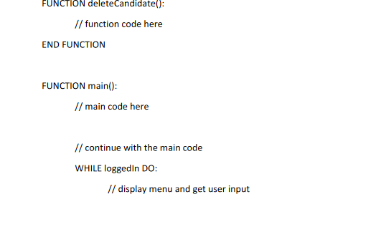

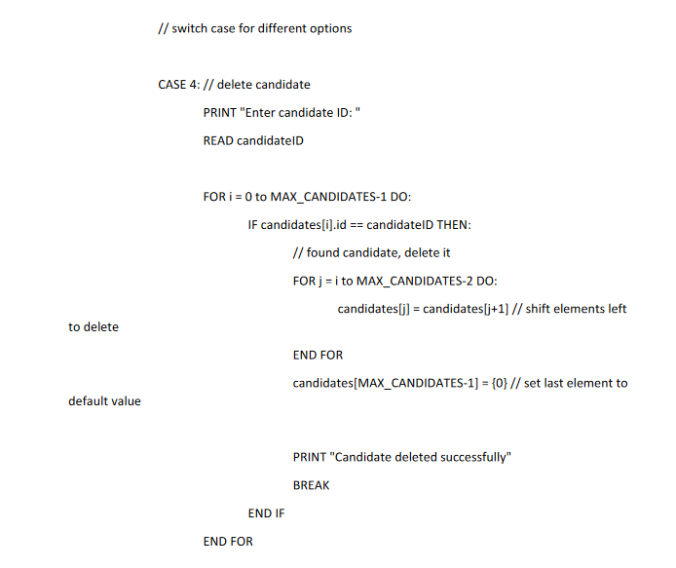

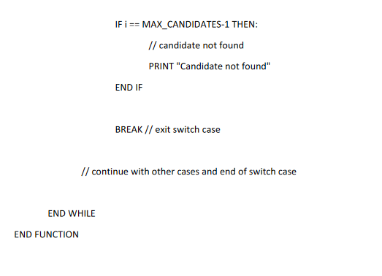

# Flowcharts:

Flow charts are useful tools that represent the program flow in symbols or visual format

In the flow chart we use mainly 3 symbols

This symbol is used for start and end the flow chart also to connect the   
2 different pages while creating flowchart.

This symbol is used to connect 2 element or flow.  
  
  
This symbol is used for processing of any program or it can also contain logic inside it.

Flowcharts connect the technical and non-technical Person to create program also it help to understand the flow of program. Flow chart also help to fix the issue in program and monitoring the program flow.

Follow is the flow chart for voting system.  
  
  
  
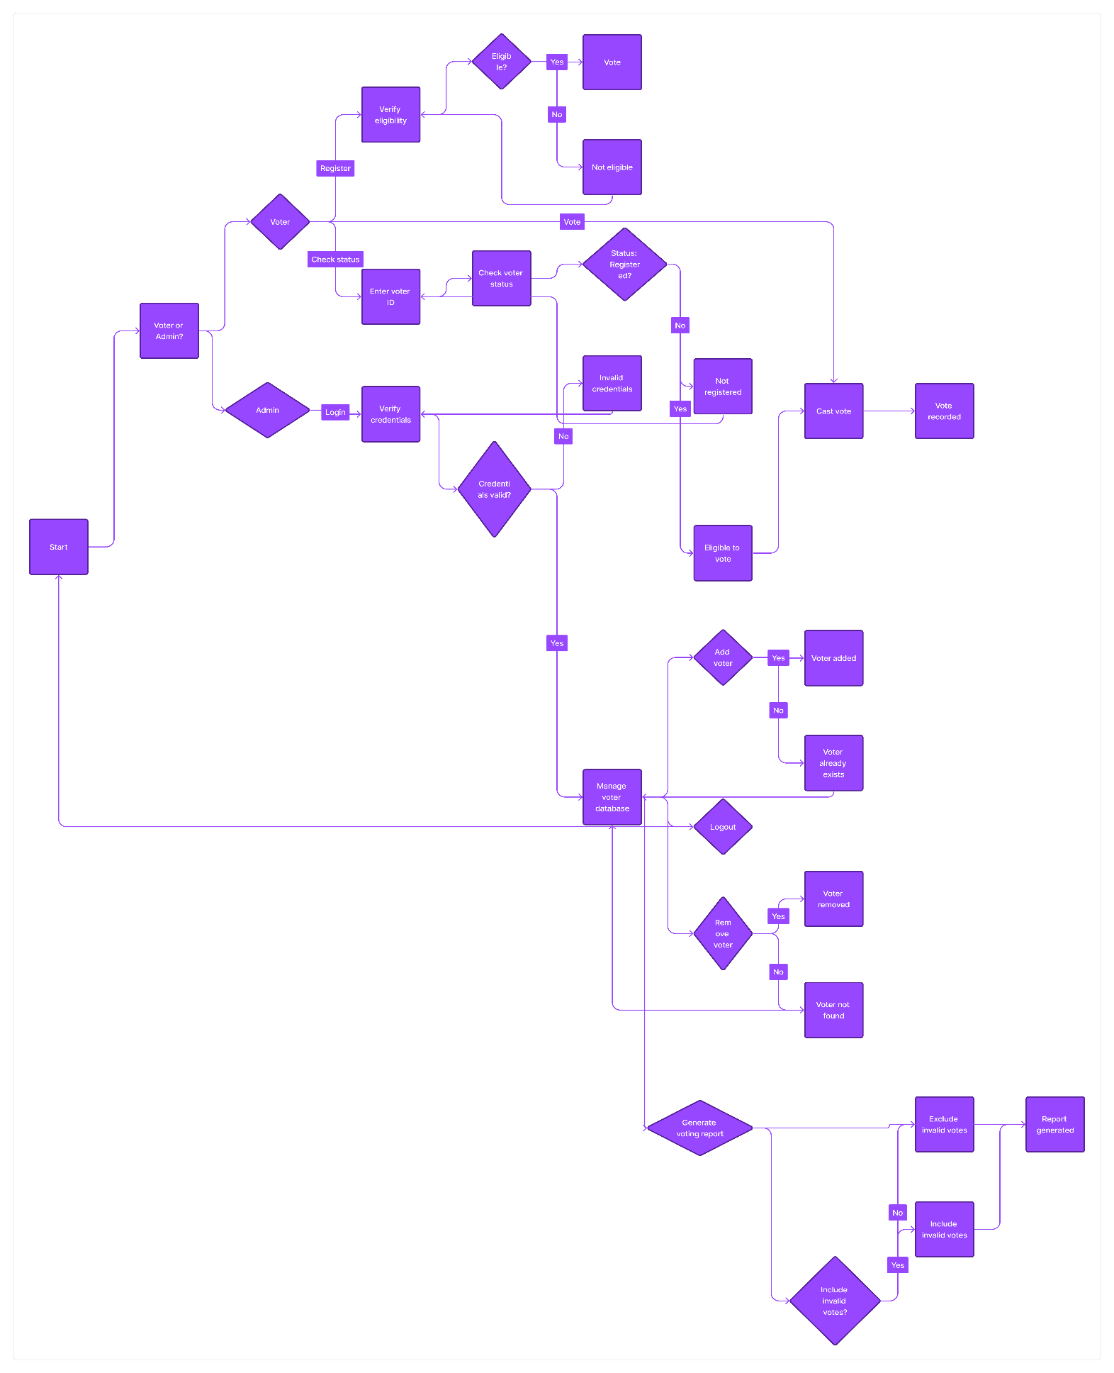

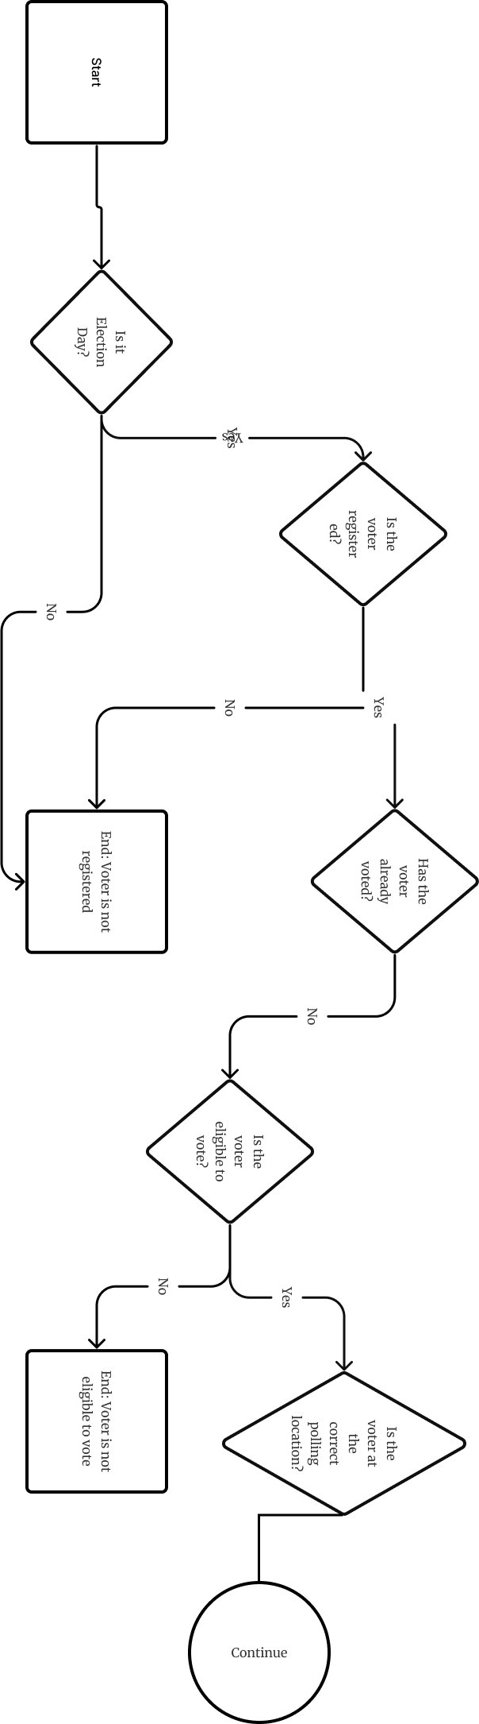

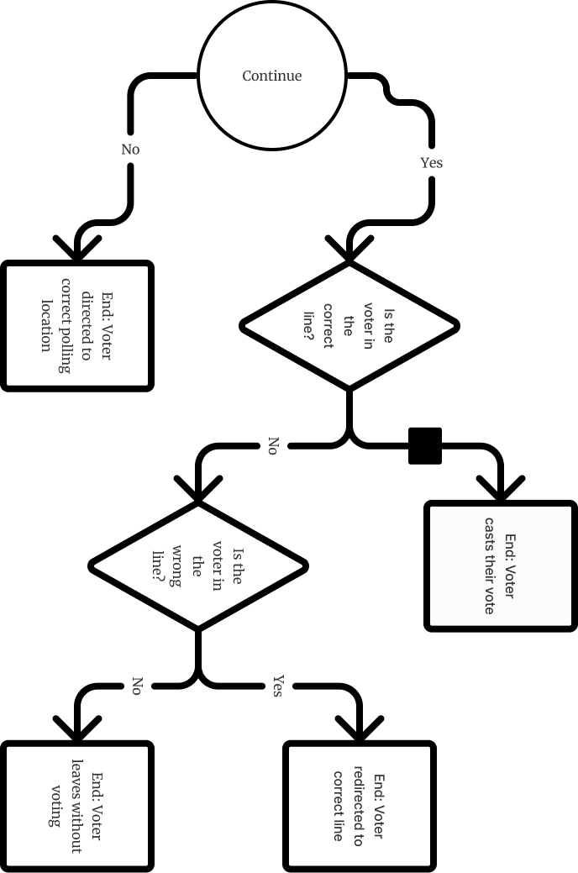

Implementation of Functions

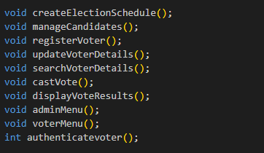

File name Generate and admin password

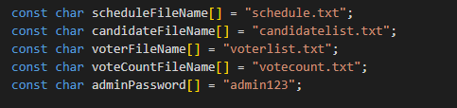

Authentication for user login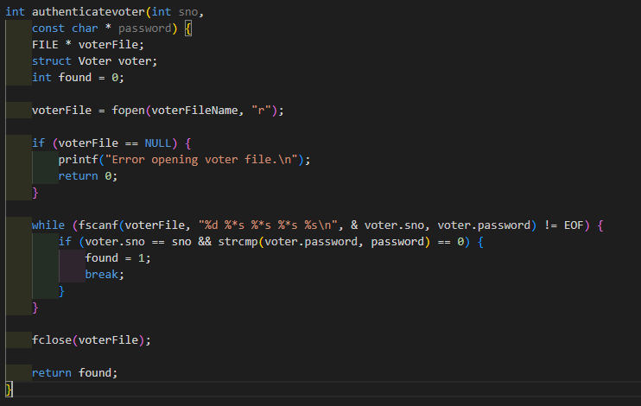

Certainly! Here are some more features to think about for my voting system, with a test code for each.

Input Approval:   
Confirm customer inputs are significant and within the planned ranges. For example, allowing the number of candidates or the user's choice while voting.

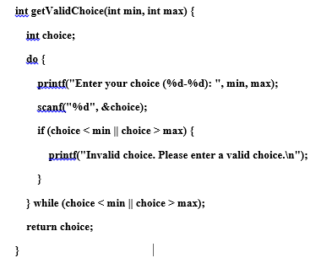

After all votes have been polled, announce the decision's champion.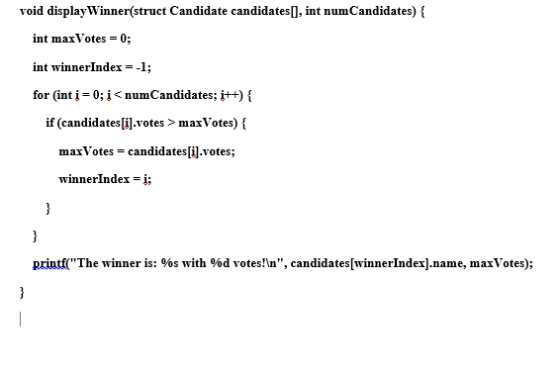

Implement mistake handling to handle unexpected situations like record I/O errors or memory allocation failures.

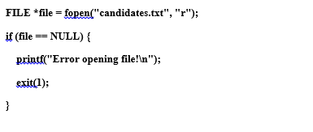

Conclusion: The creation of voting systems I learn about C programming, including POP flows, pointer functions, data types, structure, and file handling. Overall this assignment help to understand basic functions and work flows of projects.

The assignment tried to provide an accurate and user-friendly solution while creating and it teach about best practice for including modular development, validation tests, and documentation of projects.

# References

geeksforgeeks. (2023, march 15). *What is PseudoCode: A Complete Tutorial*. Retrieved from geeksforgeeks: https://www.geeksforgeeks.org/what-is-pseudocode-a-complete-tutorial/

programiz. (2021, april 5). *Flowchart In Programming*. Retrieved from programiz: https://www.programiz.com/article/flowchart-programming

skfdjskdfjs. (n.d.). *sdfsdf*. Retrieved 2014

w3schools. (n.d.). *w3schools*. Retrieved 04 15, 2023, from w3schools.com: https://www.w3schools.com/

wikihow. (2023, february 23). *Learn to Write Pseudocode: What It Is and Why You Need It*. Retrieved from wikihow: https://www.wikihow.com/Write-Pseudocode

xgxdfd. (n.d.). *xxfdxd*. Retrieved 2010

zenflowchart. (2022, march 10). *Flowchart In C Programming: Guide & Example*. Retrieved from zenflowchart: https://www.zenflowchart.com/guides/flowchart-in-c-programming

# 